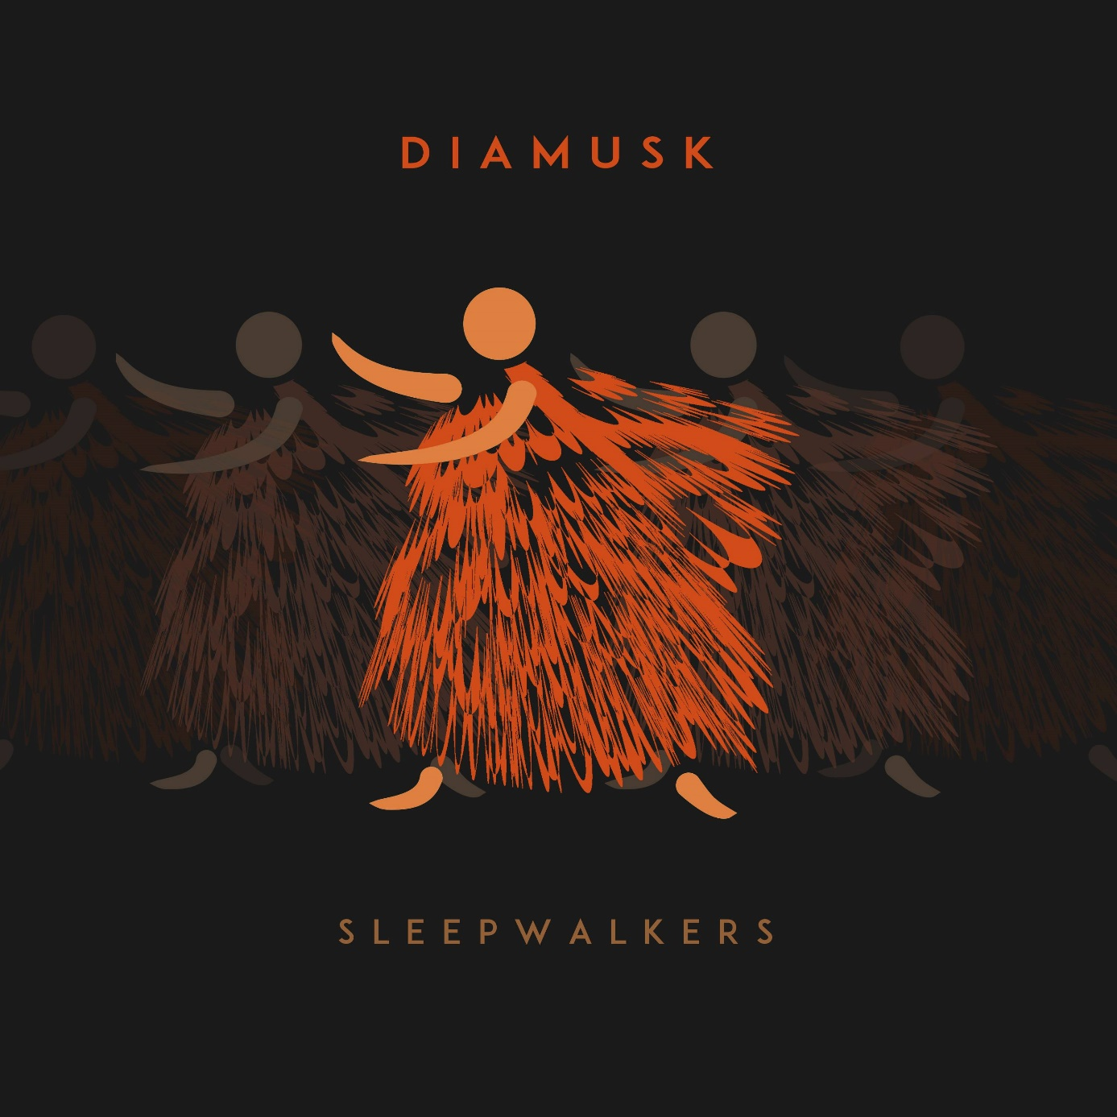
reggae dubba feat. Kiril kuzmanov

Reggae dubba time, If you don't get it, don't you sweat it Groove will walk you through this rhyme Step up hands up! To be dubby is no crime The bass will tell you what to do Just move and feel sublime We move, we dance
They won't stop us and they can't better close their eyes
And move away cause we're hot and bright like the sun Hands up and flow High up not low we're reaching for the sky! Let's flow into the sunrise Let love color your eyes We glow in the dark night Now that you get it, won't regret it It's the oneness at it's prime We dream and wait all this time and Nothing we do,
We dream and wait all this time and
It's now time to move Roots in the Babylon Silence in the Babylon
We're stirring up the Babylon Rhythm in your soul I want to make this song It's groove is gonna make you lose control One step higher, your energy's like a fire I wanna se it burn baby I wanna se it burn We move, we dance They won't stop us and they can't, better close their eyes
And move away cause we're hot and bright like the sun Hands up and flow High up not low we're reaching for the sky! Let's flow into the sunrise Let love color your eyes
We glow in the dark night
Now that you get it, won't regret it It's the oneness at it's prime


Afroheartbeat feat. Mladen Marjanovic

All that we got all that we got is
all that we'll give we won't give up
we‘ll never give up
All that we got is all that we give not to give up
Them evil better tun thema
we won't be fooled again them better surrender thema
Stronger then ever
yes yes
here we come this time we know better
yes yes
here we come no longer naive all raw here we come
Got up off our knees all loud here us stump
They hear us coming and they hear us yelling there's no more
pretending now we see them run

Hypnosis feat. Trajche velkov

What goes around comes around
Keep ya feet on tha ground
be humble be patient

Forget the weakness, give all!
There's this urge to survive, protect the core

My feet dance around the floor of the city
Two directions, weak connections
I'm the recruit of normality, neutrality
O oooo

While the storm rages outside
We forget
While the storm rages

My dear,
Don't be a fool they don't ever think of you
They re all busy thinking 'bout them selves
Same like you...

I gaze into my thoughts,
the hypnotizing slideshow
Whisper to myself
Ask and explain
I deny that which I claimed,
deny that which I claimed

While the storm rages

Outside, I forget...

Lost and found feat. Elektro Hafiz
Tell me what I've got if ya love me not
In this crowdy world one is all alone
Trapped in maelstrom of wrong
So tell me what I've got

Of the struggle nobody speaks about
Not the words but the silence is that which connects us
But tell me what I've got
If ya love me not
Tell me what I've got

See us run around
The same old place in same old ways
Now stir it up
Let it go now man change the game now man

See us lost and found
In the story someone else wrote (c'mon) now give it up
Let it go now man change the game now man

What's your cause?
Can ya hear that dinga ding dong
That gets ya up up up up than lower
Memories rewind
But all ya want all ya want
Is to look forward
Concentrated in circle,
Borderline we can't seem to cross over
So tell me what one got

See us run around
The same old place in same old ways
Now stir it up
Let it go now man change the game now man

Big Wild River feat. Nils Petter Molvær

You're trying so hard but can you succeed
Trying to decode the unknown
Wrapped in too many layers
You once believed
Once you stood
Proud now you're just a part of the crowd
And you get to learn the game of black mail
The thin thread unbreakable,
You lay low, every one will reap what they saw..

While denial remains the life style acceptable
And no resistance seem to be rentable
You fall into oblivion forgetting yourself
You're a stranger in the mirror, dreaming you live
You quiver self tortured by regret
And the blood and the sweat of life become a river
Big and wild
Life is a river big and wild river big and wild
Big and wild river big and wild you better learn to swim

Sleepwalker feat. Kenan Glavinic

I fail when I try something new
I fail when I decide that all is good
and the goal is so out of reach
hope stronger than ever
If I could only be like clever clever
like really clever I'd step up and say:
That's what I want that's what I demand!
I want nothing more but to live my own life
out of the building, out of the concrete
out of the grey
Out of the rivers of people walking the same steps each day, out of the grey!
You block me, you manipulate me, you try to control me
I sleepwalk with woken heart, you try to block me to manipulate
me you try to control me, I sleepwalk with woken heart
I want nothing more but to live my own life, out of the building
out of the concrete, out of the grey

Corridor feat. Dino Mangafic

Where's the rebellion is it hidden is it gone the oppressed
we got to get up and move up all as one
Feel stuck lost alone and done
Nowhere to go no place to run
From sleep we gotta wake up and fight against oblivion
Through corridor, let go their lies let's be one
Gotta prove myself that i can
Gotta prove my self that I can
Be yours be whole be as one
Do you hear the sound you gotta
get up and when you're feeling down you
gotta get up when you feel down
Life is hard on you you gotta get up
Believe and follow through you gotta get up and
when you fall down
you get up

Hypnosis feat. Trajche velkov

I call you out, gotta call you out Give me all you got
Forget the fear and doubt Scream and shout!
Wanna feel it clear and proud There's nothing to lose
Just be yourself out loud, come on!
Give me what I want
Can you feel it in the sound
Your body's moving so slow
Your warmth is all around It dances with the sound
All as one we now flow Feeling who we are
Never to forget, and we want more No, we won't stop
Yes we can't stop Being who we are
Driven by the sound of love See us together and the hope arise
I don't ever want to let this go yeah Free of doubt, fear and all
their lies
We defy division with equality yeah I give you what you want
I can feel it in the sound My body is moving so slow
My warmth is all around It dances with the sound
All as one we now flow Feeling who I am
Never to forget And I want more!
No I won't stop Yes I can't stop
Being who I am
Driven by the sound of love <3

Another beginning Feat. Bjørn Blomberg

No matter the day things gone the wrong way
No matter the news they don't entertain me
No matter the done no matter it cannot be undone
No matter the dreams stuck in between
The worlds we must choose
No matter the rain sunshine will surely come
No matter the moon and the wolfs howling
No matter the end its another beginning

Where ya gonna run run who ya gonna who you gonna lie lie
What you gonna what you gonna find find what is the goal of the
worry all the worry won't change
All you all along well know

No matter the moon and the wolfs howling
No matter the end its another beginning
No matter the rain sunshine will surely come
No matter the moon and the wolfs howling
No matter the end its another beginning

Recall feat. Djani Pervan

Can you Tell me what it is tell me who we are
Tell me if ya know why is it so tell me if ya know
can u show me how to be
Be like
Be like the trees
Be like the sea and like the stars and breath in breath out smile there is no good escape from now
Life is a mystery to live is brave and so beautiful and hard
Recall the good the pure the real now
Soon to be woken soon to be great and
Don't hold on hold on
I need to spill the lines
I need to scream it out of me, the indescribable
i need to locate it wrap my mind around it
i need to learn the lesson and carry on
carry on wiser see the spot at the end of the tunnel a little brighter
see all together a little lighter
refocus the focus off what is out of the focus and just carry on
It isn't something we know but feel!
Can you Tell me what it is tell me who we are
Tell me if ya know why is it so tell me if ya know
can u show me how to be
Be like

